`

Dear Student,

You can take All India Mock Tests by following the below steps.

**Step 1:** Login in to <https://learn.talentsprint.com/>

Enter your **email id** (which is registered for TalentSprint) and **password**. Click on “**Log into My Account**”

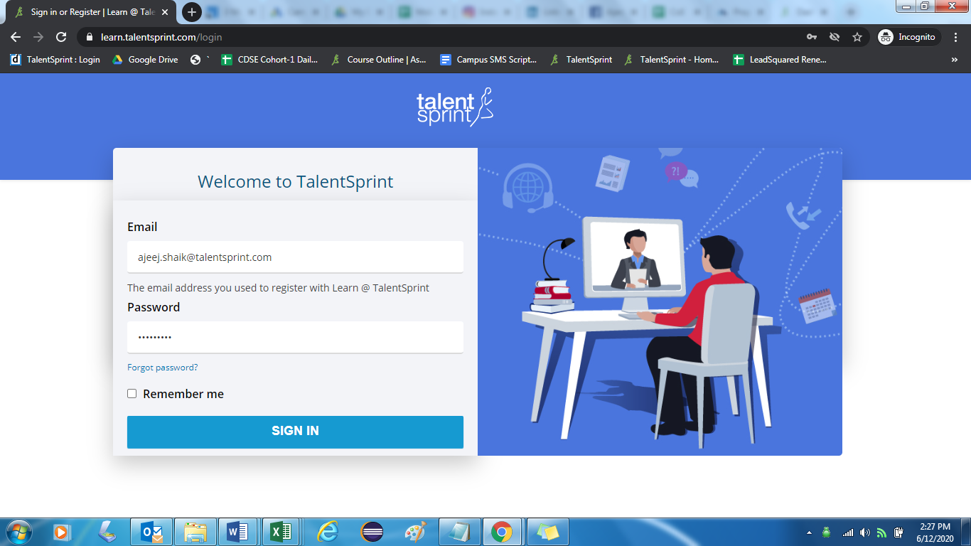

**Step 2:** Once you login to the account you can click on the “**Practice Tests”** (you can find it in right side)

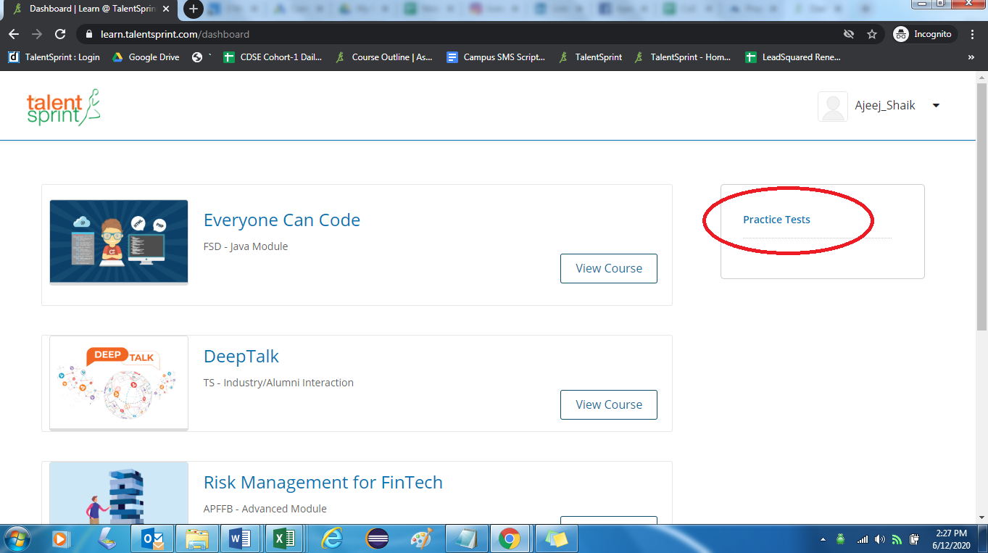

**Step 3:** Once you clicked on practice tests it will redirect to **http://practice.talentsprint.com/testlist**

Then you can type the test paper name in **Search Box**.

(If you are unable to find the test papers please click on the “**Didn’t find all tests? “Click Here.** You can find this option in the top right side of the page.

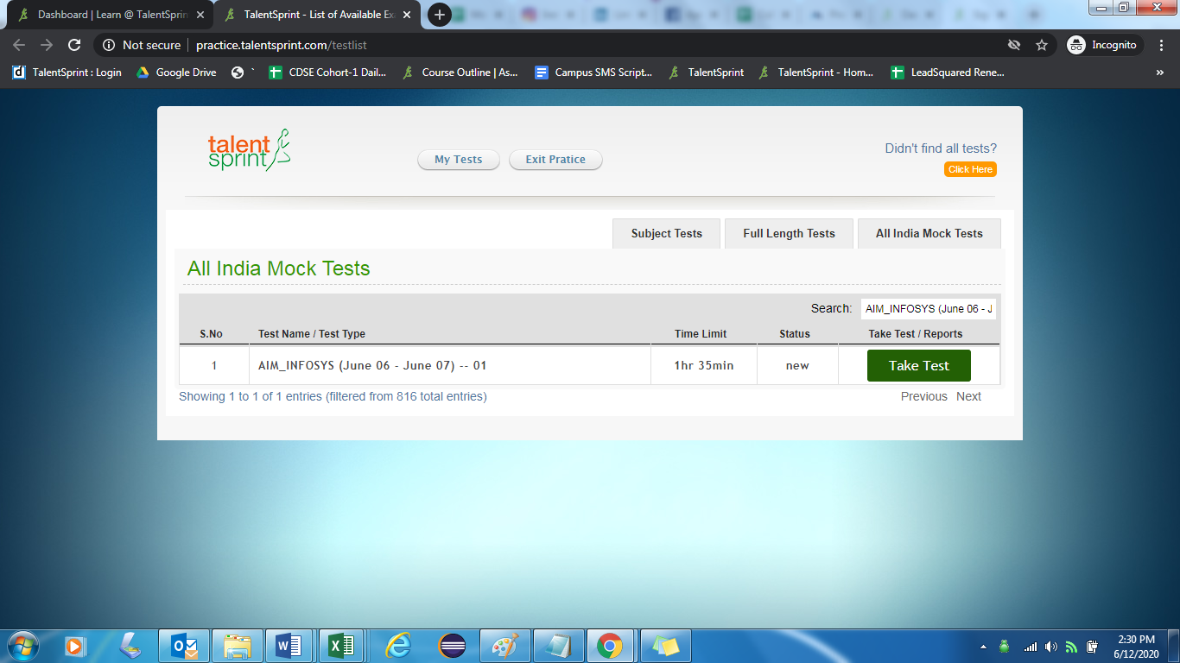

**Step 4:** Once you found the test paper, click on **Take Test**

Then read the test instructions and start the test.

Once you complete each sections please click on “**SUBMIT”** and click on **OK.** With this that particular section will be submitted and then automatically next section will begin.

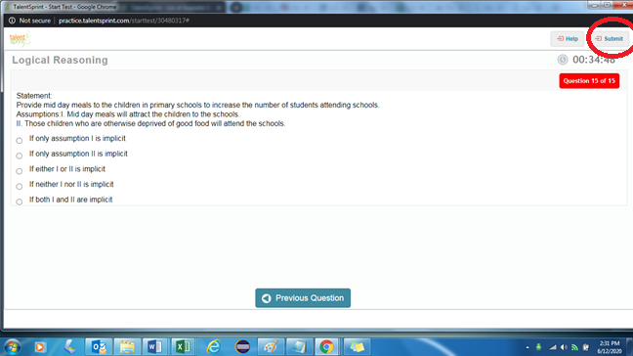

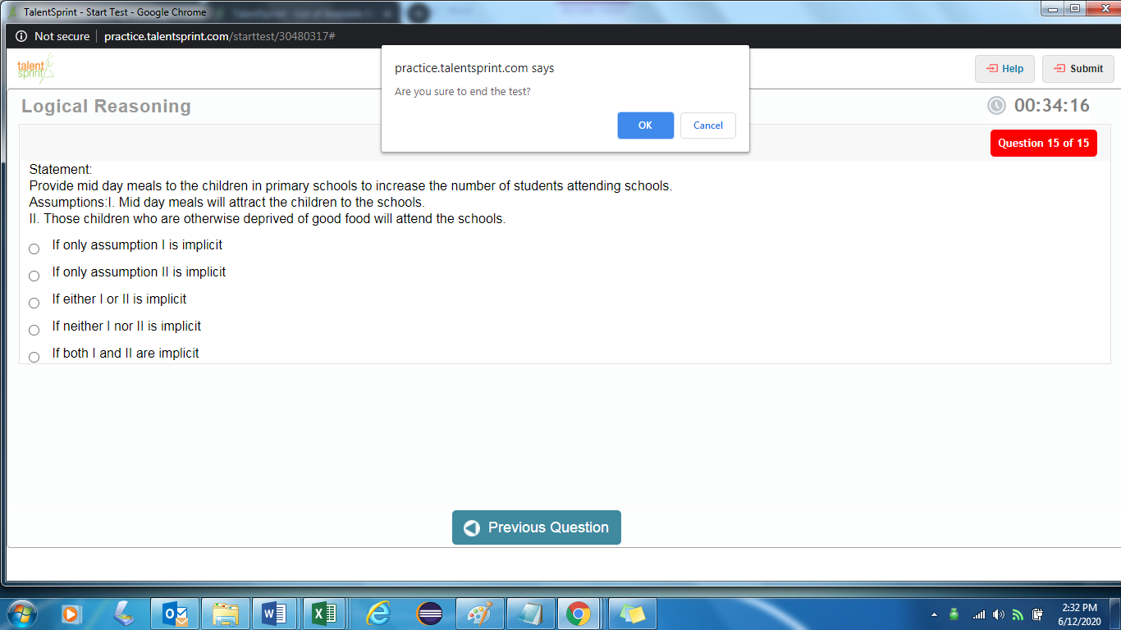

All the best!

Best Wishes

TalentSprint